1.0 Introduction
1.1 Purpose and Scope
The purpose of this project is to develop a web-based forum application that enables students to communicate, share information, and engage in discussions efficiently through an online platform. The application allows admin and moderators to manage forum content and user activities to ensure a structured and positive communication environment. This system aims to enhance collaboration among students while providing a centralized space for academic and non-academic discussions.
The application is supported by a relational database that stores information related to admin, moderators, and student users. The database also manages forum post and user interactions. With a focus on accessibility and usability, students can access the forum using various devices such as computers and tablets while experiencing consistent functionality and user experience across platforms.
The forum application provides effective reporting and monitoring features, allowing admin and moderators to view user activity and manage reported content. Students can easily view the status of their posts and interactions through their user dashboard. This ensures transparency and encourages active participation within the forum.
Overall, the application allows educational institutions and student communities to efficiently manage online discussions with minimal effort. Admin can moderate, edit, or remove content with just a few clicks, while students can communicate and collaborate without relying on traditional communication methods such as emails or messaging applications. This reduces administrative workload and fosters an engaging, well-organized online communication platform for students.
Definitions, Acronyms and Abbreviations
Acronyms/Abbreviations/Words | Definition
SRS | Software Requirement Specifications
DB | Database
SCM | Software Configuration Management

1.2 Overview
The SRS describes the overall characteristics and scope of the web-based forum application developed to support student communication and interaction. This document presents a general description of the system from both product and user perspectives, including identified constraints, assumptions, and dependencies that may affect the system’s design and implementation. In addition, it details all relevant system interfaces, including user interfaces, software interfaces, communication interfaces, and any applicable hardware considerations required for the operation of the web application. The functional requirements of the system are illustrated using Use-Case Diagrams to clearly define interactions between users and the system, while the non-functional requirements such as performance, usability, security, and reliability are also specified. Analysis models are applied to further clarify and structure the system behaviour. These models serve multiple purposes, including validating requirements and ensuring that the system meets user needs once development is complete. Various diagrams are used within the analysis model to represent system processes, data flow, and interactions. The change management in the software requirements will also be explained in the later part of this document.

1.3 General Description
This document explains the challenges and issues encountered during the development of the web-based forum application, which may impact the project’s progress and scalability. It describes the requirements and ideas requested by the clients and proposed solutions designed by the development team. The document also summarizes the key software features and proposed system components. The system requirements including functionality, security, supportability, constraints, and interfaces are briefly explained.

2.0 Product Perspective
The web-based forum application is specifically designed for a university to facilitate communication among students, lecturers, and administrators. This application provides functionalities like online discussion forums and academic collaboration platforms. It interfaces with a MySQL relational database connected to a web server and supporting services such as a storage server. The primary users of this application include admins, moderators, and students. To operate effectively, the system requires user management, forum and discussion management, and administrative control of the application. This system architecture is illustrated in the following figure.
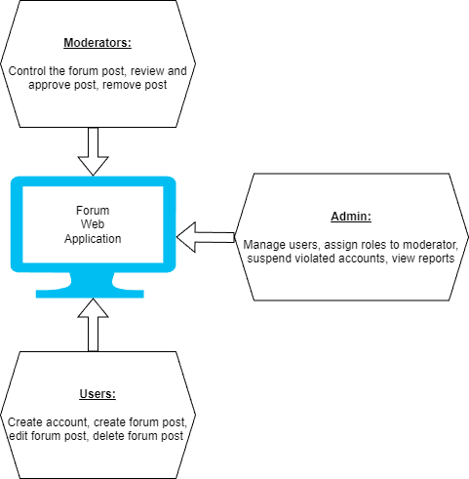
Each group works with a dedicated server or module. All of them run on a local server (XAMPP or PHPmyadmin) of the web forum application. The admin and moderator module can manage and control the forum environment from each user. Every person needs their credentials to login into the system such as username and passwords.
All of them can be reached using web interfaces such as Google Chrome, Firefox, etc.
3.0 Product Functions
This product will have functionality like common online community or membership-based platforms. For example, the system is designed for use within a university environment to support communication and discussion among its members. Users of the forum will have individual accounts that allow them to create posts, participate in discussions, manage their profiles, and edit or remove their own content.
Moderators are responsible for managing discussion activities by reviewing, approving, editing, or removing posts when necessary. They can also monitor forum activity and use discussion statistics to ensure productive and appropriate communication within the platform.
The system also maintains records of university users, including students and staff, to support effective content management and user interaction. Upon registration, users are added to the system and granted access based on their assigned roles.
Admins have full control over the system, including managing user accounts, assigning moderator roles, and removing or blocking users when required. Admins can also manage overall system settings to ensure smooth and organized operation of the web-based forum application.

4.0 User Characteristics
The users of this software are mainly classified in three categories:
User
- The student who are trying to find any knowledge or information in the internet via forum post
- The student may or may not be very familiar with using the web application
Moderator
- The user that will be handling mostly the web application
- Needs to have basic knowledge of using the web application and capable of handling student’s forum post through the application
- The user must have common sense and not be biased toward any forum posts made and shall able to maintain safe environments in the web application
Admin
- The user that will mainly in charge of managing the application
- Adding and deleting the users and moderators of the application
- Recruit new moderators to help manage the application.
- Aid the moderators in case of any issues.
Each user has different expectations from the web application that is being developed
User
- Wants to view, make and delete forum post
- Wants to search for specific forum post
- Wants to report on inappropriate forum post or comment
Moderator
- Wants to review and remove the inappropriate forum post
- Wants to assist the user about the web application
Admin
- Wants to have ability to be the main controller of the application
- Wants to control the access and usage capabilities of the other types of users
- Wants to assist the moderator about the application

5.0 General Constraints
Fully functional Internet network connection and 24-hour server uptime for optimal functionality are required for the proposed solution. In the case when there is a loss of Internet connection or server downtime during any active session from the user, an error message will be displayed such as “temporarily lost network connection” or “Server not found”. The error message will depend on the occurrence of the error. Hence, to counter this issue, the user needs to perform the task again upon resumption of Internet network connection and server.

6.0 Assumptions and Dependencies
During the software development, it is assumed that the university will utilize computer hardware running a Windows operating system, specifically Windows 10 or later. It is also assumed that the university will provide the necessary server infrastructure to host the application and its database.
The system depends on the availability of at least two servers for data storage, where one server is used for primary data management and the other for data backup. A registered domain is required to allow users to access the forum through a web interface. The web application must have authorized access to the database to retrieve and store user, post, and discussion data. In addition, users accessing the forum are required to have a compatible device and a stable Internet connection to ensure proper system functionality.

- Functionality and Features
7.1 Requirements
Feature 1 <Register new user / Login>
New users should be able to register a new account by entering their university’s email address, password, username, gender and contact number in the register page. Then, their entity will be created in the database. For existing users, they are required to login using the credentials before they can enter forum website.
Feature 2 <Make / View / Edit / Delete a forum post>
The existing users must be able to view all the forum posts made from other users. Not only that, but they must also be able to make a new forum post. The forum made by them should be viewed, edited and deleted by themselves.
Feature 3 <Moderation>
The existing users should be able to report any forum posts if they find it inappropriate or break the rules and terms and services. The reported posts will be reviewed by the moderators and will be removed if it is deemed necessary.
Feature 4 <Admin management>
The admin should be able to add, remove, edit and delete any existing users or moderators from their access. The recruitment of moderators is also made by the admin to aid them in any issues.

7.2 Use Cases
Web-based forum application
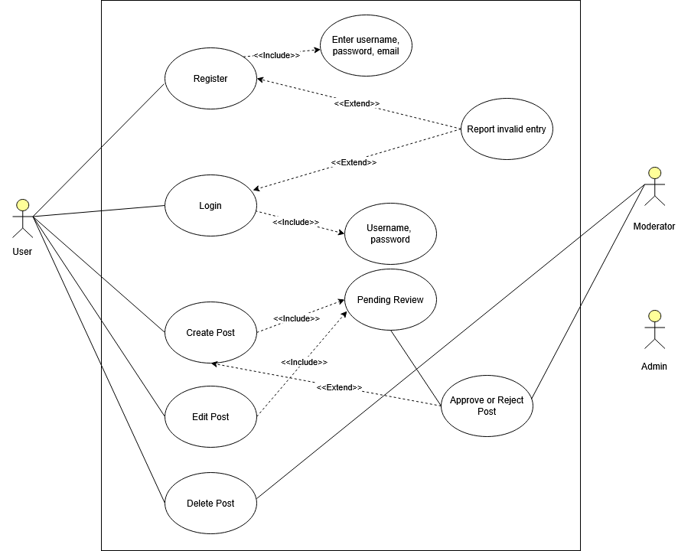
Use case diagram from users’ point of view
Name/Description | User and Moderator Use Cases
Actors | - User  - Moderator  - Admin
Main Success Scenario | - The user accesses the Forum Web Platform and registers an account by entering a valid username, password, and email. After successful registration, the user logs into the system using valid credentials and gains access to the platform features.  - The user then creates a post, which is automatically submitted for pending review. A moderator reviews the post and approves it, after which the system publishes the post and makes it visible to other users. The user may subsequently edit or delete their post as needed while using the platform.
Alternate Flows | - If the user enters invalid or incomplete information during registration or login, the system reports an invalid entry and prompts the user to re-enter the required details. If a submitted post is rejected by the moderator, the system updates the post status to rejected and notifies the user, who may choose to edit and resubmit the post for another review.  - At any point after creating a post, the user may also choose to delete the post, in which case the system removes it and terminates the posting process.

Web-based forum application
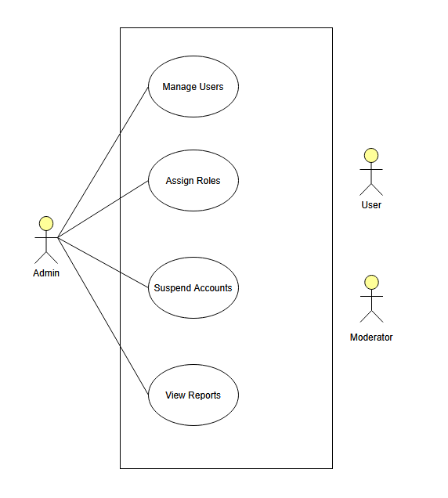
Use case diagram for admin’s point of view
Name/Description | Admin Use Case
Actors | 1. Admin  2. Manager  3. User
Main Success Scenario | - The admin account must exist in the system and have valid administrative privileges. The Forum Web Platform and database must be operational, and the admin must be successfully authenticated before performing any administrative actions
Alternate Flows | - If the admin attempts to manage users or assign roles to a non-existent or invalid account, the system displays an error and prevents the operation.  - If a role assignment or suspension action cannot be completed due to system errors or insufficient privileges, the system notifies the admin and no changes are applied.  - When viewing reports, if report data is unavailable or a system failure occurs, the system informs the admin and allows the admin to retry or exit the function.
Pre-Conditions | - The admin account must exist in the system and have valid administrative privileges. The Forum Web Platform and database must be operational, and the admin must be successfully authenticated before performing any administrative actions.

7.3 Sequence Diagrams
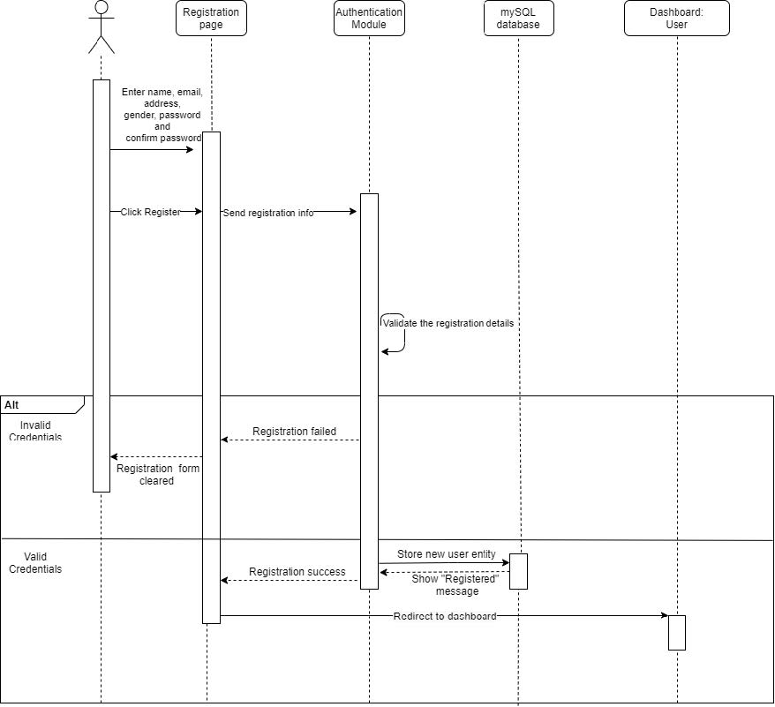
Sequence diagram of registration
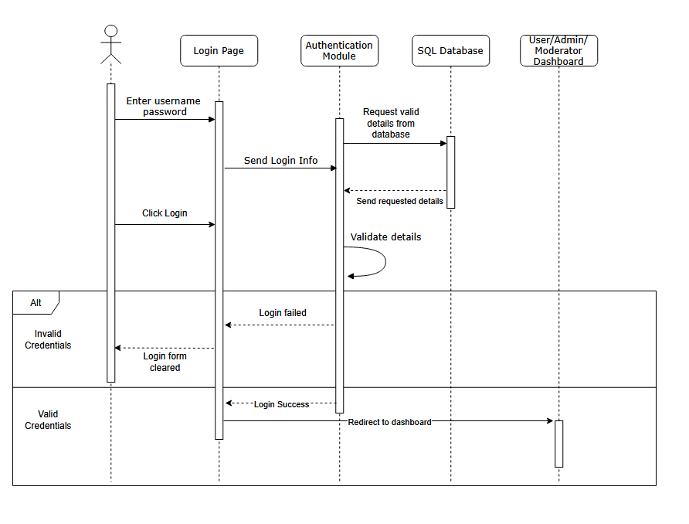
Sequence diagram of login
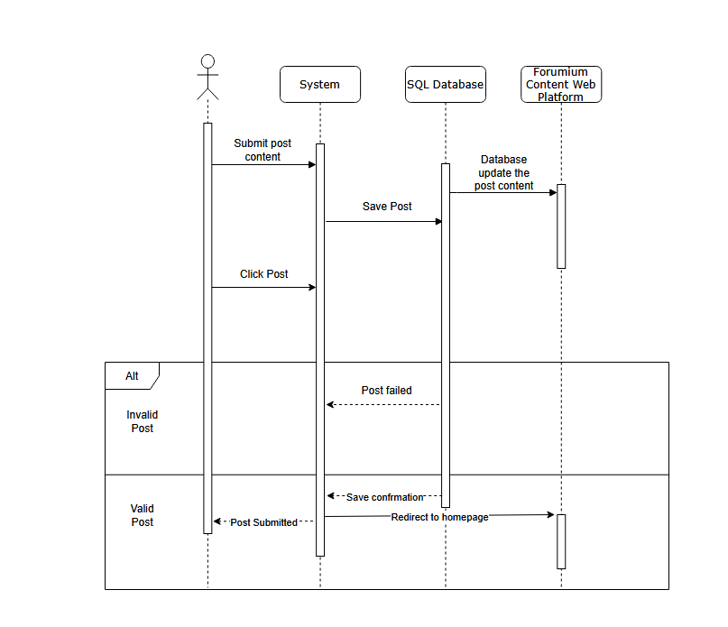
Sequence diagram of creating a forum post
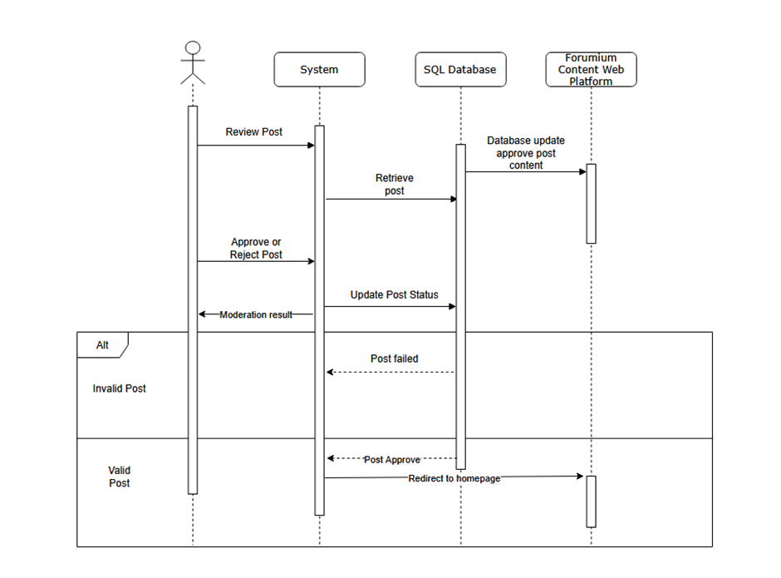
Sequence diagram of moderating forum post

Analysis Models
Data Flow Diagrams (DFD)
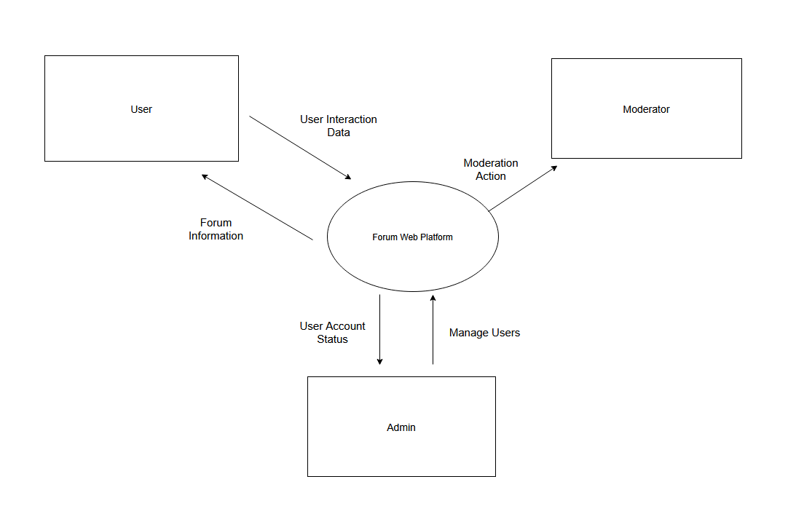
Level 0 - DFD
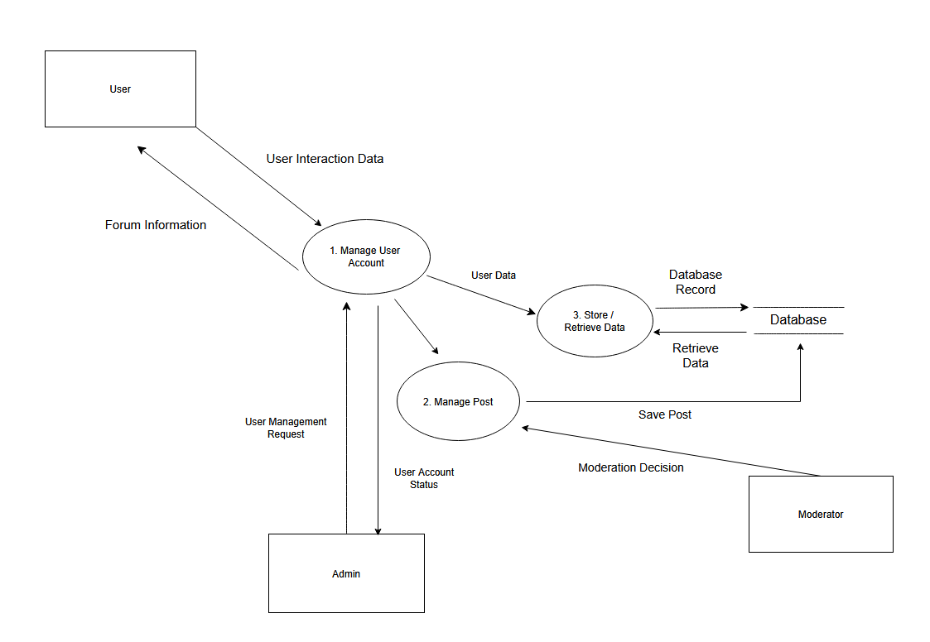
Level 1 - DFD
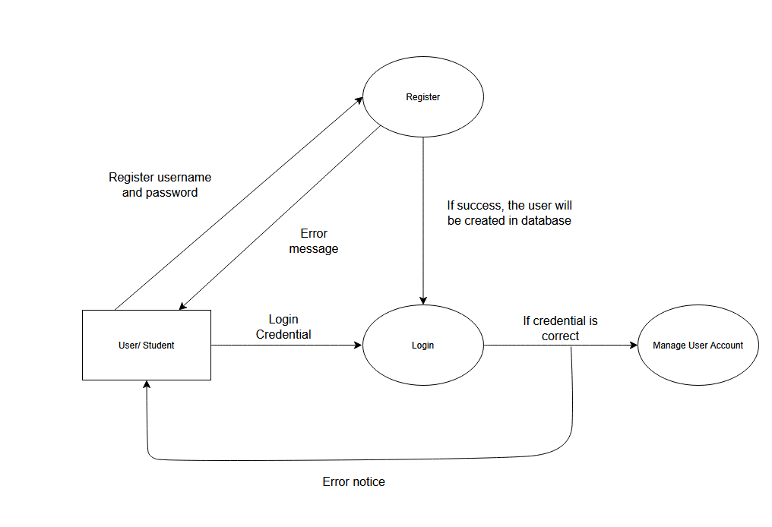
Level 1 – DFD for registration/login (extra)
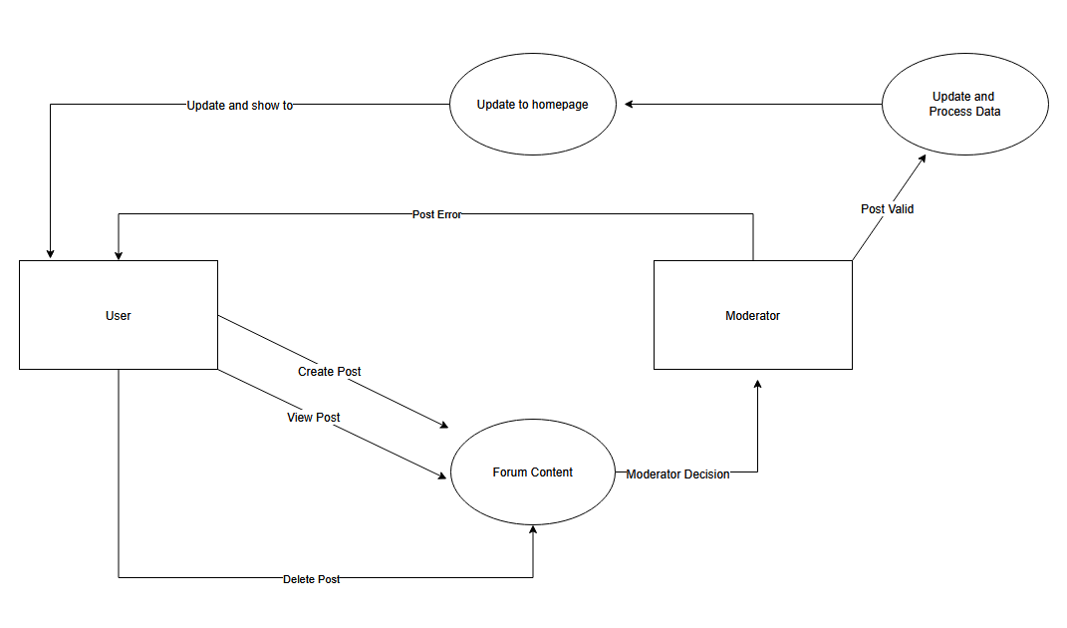
Level 1 – DFD for creating, viewing and delete forum post content (extra)

State Flow Diagrams (STD)
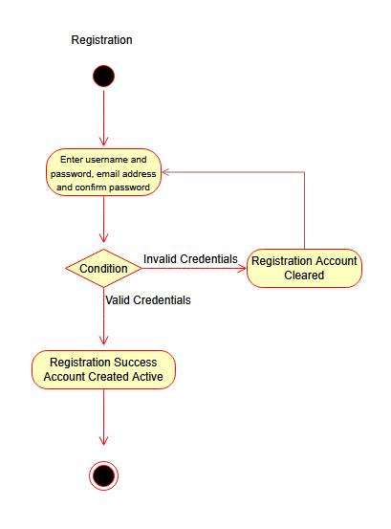
UML diagram for registration
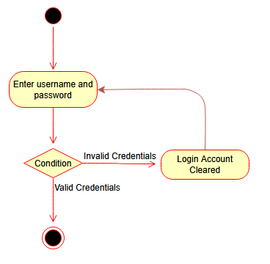
UML diagram for login
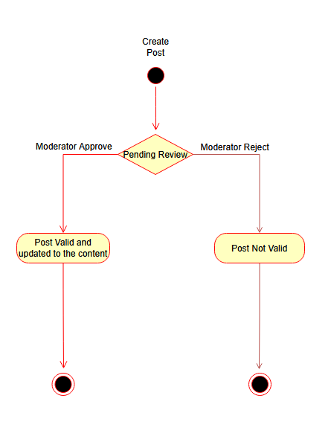
UML diagram for user created post lifecycle

8.0 Specific Requirements
The web-based forum application is developed to provide an efficient platform for student communication and discussion within a university environment. The system must include features that allow users to create, view, edit, and delete forum posts across various discussion categories. The application should offer a clear and user-friendly interface to ensure users can participate in discussions without confusion.
In addition, the system enables university personnel such as admins and moderators to manage, monitor, and organize forum activities effectively. This includes moderating content, managing user roles, and overseeing discussion engagement. The system supports efficient resource utilization by reducing the need for manual communication and enabling streamlined online interaction within the university community.

8.1 External Interface Requirements
8.1.1 User Interfaces
1. The user interface for this web application is simple, easy to use and efficient.
2. The user interface should minimize the number of clicks to make each transaction. Any unnecessary pages are not tolerant and should be removed.
3. The user interface should minimize all the animation and fancy effects to reduce the probability to “hang” for low spec devices
8.1.2 Hardware Interfaces
1. To utilize this web application, Internet access will be required. Hence, there should be a connection between the user and the Internet.
8.1.3 Software Interfaces
1. Database should be consistent with records and data for every transaction update.
2. Databases should be updated from time to time.
3. Only administrators are allowed to access into the database and alter the setting or remove the setting.(Full access)
4. Forum web application shall communicate to the database to save user account, forum post, admin, and moderators details.
5. Users with any OS should be able to access the application unless his/her devices do not support internet access and browsers.
8.1.4 Communication Interfaces
1. This project supports all types of web browsers.

9.0 Non-Functional Requirements
9.1 Performance
1. Forum web applications by Flarem need to be hosted on the internet to serve and provide its service. Since this application is a simple program, therefore, most devices available today no matter its low end, mid end or high-end device should be able to run this application smoothly and perfectly
9.2 Reliability
1. The system must be free of any kind of bugs and inaccurate results
2. The application should work properly and consistent for any users
9.3 Availability
1. The application should be available in any device with internet connection and web browser
2. The application should be available on the DNS 24/7. To achieve this, the contractual agreement should be done with ISP so the system will ensure high availability on the internet.
9.4 Security
1. When a user closes the browser, the user will automatically log out.
2. The login page will not display the user’s password when he/she is typing.
3. Only admins are allowed to alter the users and moderators' entities.
4. The database shall be encrypted.
9.5 Maintainability
1. After the application is created and before/after release, the app will constantly release updates to improve and maintain the user satisfaction or user experiences towards this application. These updates will mostly depend on the feedback and comment by constantly doing surveys (refer to Software Quality Assurance Document).
9.6 Portability
1. The application should be able to be accessed by any means such as tablets, smartphones or laptops. It is because this application is just a web application.

Meeting Minute with University
Two meetings were held to discuss and gather the requirements of the system. During the first meeting, both parties restate their original intent on the project. The second meeting discussed the business operation and problems faced by the client.
First Meeting
10 November 2025 | 11:00 AM – 12:00 PM | Google Meet
Type of meeting | Get together meeting
Note taker | Luqman Eman bin Aiman (University)  Akmal Danish (Flarem)
Attendees | (University)  Muhammad Abu bin Ali – Director of University  Wan Nabil bin Abdullah – Operational Manager  Luqman Eman bin Aiman – University Main Representative  (Flarem)  Faris Amsyari – Project Manager  Syafiq Haikal – <need role>  Muaz – <need role>  Akmal Danish – Lead Programmer
Forum Web Application Project Proposal Review
30 Minutes | Akmal Danish
Discussion | - Presentation of Project Proposal by Flarem to University  - System Diagram presentation of the web application  - General presentation on roles and responsibilities of Flarem
Conclusions | - Flarem will build a Forum Web Application for University.  - The Proposal is recognized by University.  - Both parties will clearly communicate the requirements.  - To achieve 3, another meeting will be held on identifying University strategy and the system analysis and design.
2) University Tender Review
30 Minutes | Luqman Eman bin Aiman
Discussion | - Presentation of Tender by University  - Key problem areas are defined
Conclusions | - Flarem provided acknowledgement on coming up with a System Requirement Document.  - Meeting on gathering requirement scheduled on 12 November, time 2:00 PM to 4:00 PM
Action Items | Person Responsible | Deadline
Meeting Notice to be sent to all through email | Faris Amsyari | 11 November 2025
Second Meeting
12 November 2025 | 2:00 PM – 4:00 PM | Google Meet
Type of meeting | Gather detailed requirements meeting
Note taker | Luqman Eman bin Aiman (University)  Akmal Danish (Flarem)
Attendees | (University)  Muhammad Abu bin Ali – Director of University  Wan Nabil bin Abdullah – Operational Manager  Luqman Eman bin Aiman – University Main Representative  (Flarem)  Faris Amsyari – Project Manager  Syafiq Haikal – Software Quality Assurance (SQA)  Mir Mohammad Muaz – SCM  Akmal Danish – Lead Programmer
Welcoming and Introduction – 30 minutes
- Faris Amsyari welcomed all members of the meeting.
- Restate of meeting purpose – to gather requirements.
- Muhammad Abu talked about the University strategic goals
Requirement Gathering Meeting
1.5 hours | Moderator: Akmal Danish
Discussion | - Wan Nabil provided information on the current operation  - Operation and problem faced by University  a. The university currently uses multiple channels (email, messaging apps, in-person communication) for academic and non-academic discussions.  b. Managing communication across these disconnected platforms has become inefficient as student numbers increase.  c. Informal platforms used by students lack proper organization, moderation, and record-keeping.  d. Important announcements and discussions may be missed or duplicated due to the lack of a centralized system.  e. University management has identified the need for a centralized web-based forum to improve communication and information access.
Conclusions | - The university requires a centralized and structured platform to manage student communication and discussions effectively, as existing methods are fragmented and inefficient.  - Therefore, there is a need to introduce a digital, web-based forum solution to support organized interaction and information sharing.  - Flarem will prepare the System Requirements Specification document in accordance with the agreed project backlog.
Action Items | Person Responsible | Deadline
System Requirement Document | Flarem | 12 December 2025

